**FINAL REPORT**

**HematoVision: Advanced Blood Cell Classification Using Transfer Learning**

**TEAM ID: LTVIP2026TMIDS24427**

**1. INTRODUCTION**

1.1 Project Overview

1.2 Purpose

**2. IDEATION PHASE**

2.1 Problem Statement

2.2 Empathy Map Canvas

2.3 Brainstorming

**3. REQUIREMENT ANALYSIS**

3.1 Customer Journey map

3.2 Solution Requirement

3.3 Data Flow Diagram

3.4 Technology Stack

**4. PROJECT DESIGN**

4.1 Problem Solution Fit

4.2 Proposed Solution

4.3 Solution Architecture

**5. PROJECT PLANNING & SCHEDULING**

5.1 Project Planning

**6. FUNCTIONAL AND PERFORMANCE TESTING**

6.1 Performance Testing

**7. RESULTS**

**8. ADVANTAGES & DISADVANTAGES**

**9. CONCLUSION**

**10. FUTURE SCOPE**

**11. APPENDIX Source Code(if any) Dataset Link GitHub & Project Demo Link**

**1. INTRODUCTION**

**1.1 Project Overview**

HematoVision is a Deep Learning-based medical image classification system developed to automatically identify and classify different types of blood cells using Transfer Learning techniques. The system is designed to assist in hematological analysis by accurately detecting blood cell categories from microscopic images. By leveraging Convolutional Neural Networks (CNNs), HematoVision provides a reliable and efficient solution for automated blood cell classification.

In this project, a pretrained deep learning model such as **ResNet18** is fine-tuned using a dataset of annotated blood cell images. The model learns complex visual features such as cell shape, texture, nucleus structure, and cytoplasm patterns that differentiate various blood cell types. The system allows users to upload blood smear images through a web interface, processes the image using the trained model, and instantly displays the predicted blood cell category along with a confidence score.

The solution integrates:

• Image preprocessing techniques (resizing, normalization, augmentation)  
• Transfer Learning using pretrained CNN architectures  
• Model evaluation using accuracy, confusion matrix, precision, recall, F1-score, and ROC-AUC  
• Web deployment using Flask  
• Real-time prediction system

The trained model achieved high classification performance with an overall accuracy of approximately **96%** and a strong ROC-AUC score, demonstrating reliable diagnostic assistance capability.

**1.2 Purpose**

The main purpose of HematoVision is to develop an intelligent and automated system that assists in accurate blood cell classification using Deep Learning and Transfer Learning techniques.

The specific objectives are:

1. To reduce manual effort in blood cell identification.
2. To provide fast and reliable classification of blood cell types.
3. To implement Transfer Learning for efficient training with limited medical datasets.
4. To build a real-time web-based application for practical usage.
5. To support medical diagnostics with AI-based image analysis.

**2. IDEATION PHASE**

**2.1 Problem Statement**

The identification and classification of blood cells are traditionally performed through manual microscopic examination by laboratory technicians and pathologists. This process is time-consuming, labor-intensive, and highly dependent on human expertise. In high-volume diagnostic environments such as hospitals and laboratories, manual classification becomes inefficient and prone to human errors due to fatigue, variations in lighting conditions, and subjective judgment.

With the increasing demand for accurate and timely medical diagnosis, there is a need for an automated, reliable, and scalable system that can classify blood cells quickly and accurately. Traditional methods lack automation and cannot efficiently analyze subtle visual patterns present in microscopic blood images.

Therefore, the problem addressed in this project is:

To develop an intelligent image-based classification system using Deep Learning and Transfer Learning techniques that can automatically detect and classify different types of blood cells with high accuracy, thereby reducing manual effort, minimizing diagnostic errors, and improving healthcare efficiency.

**2.2 Empathy Map Canvas**

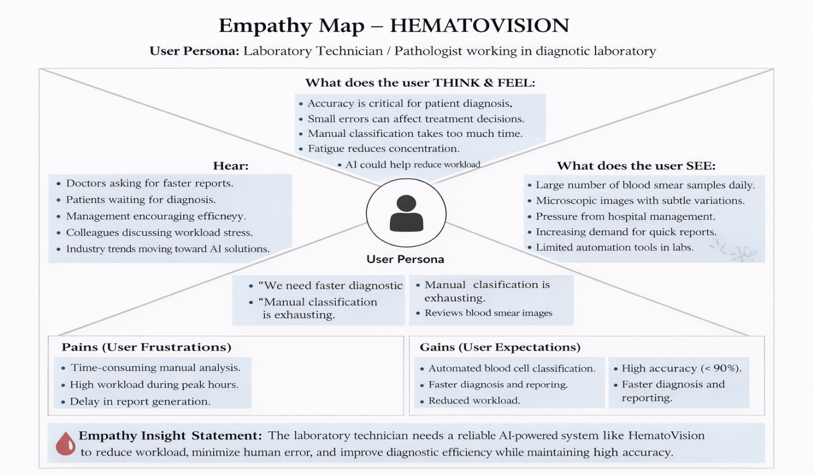

**2.3 Brainstorming**

**2.3.1: Team Gathering, Collaboration and Select the Problem Statement**

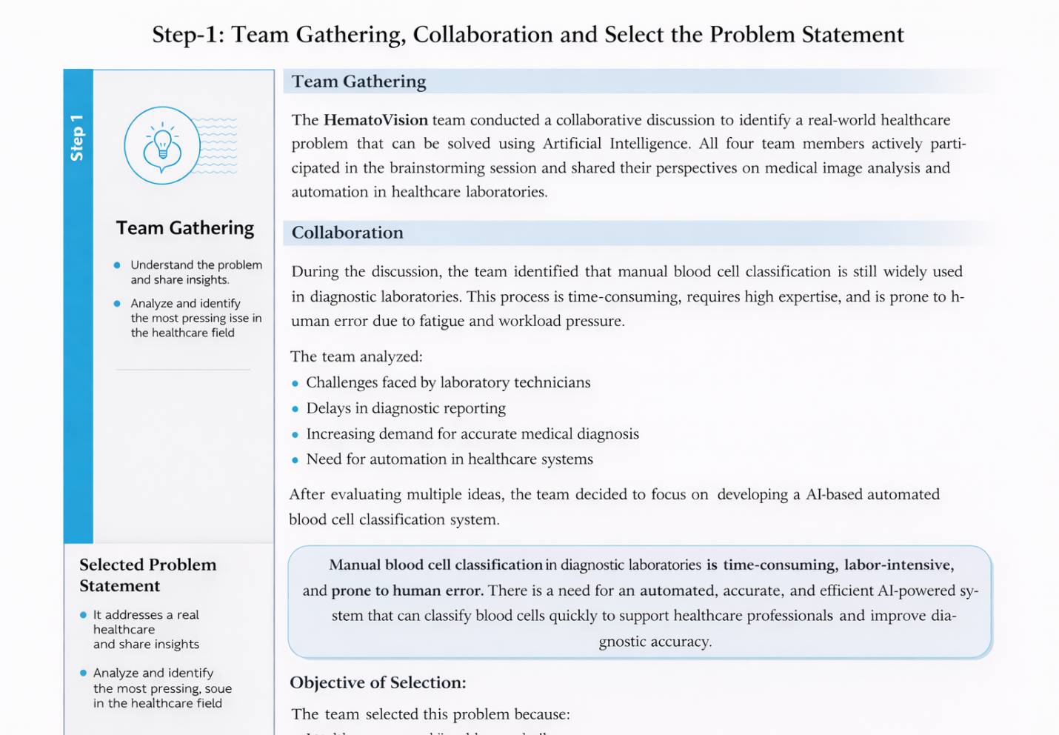

**2.3.2: Brainstorm, Idea Listing and Grouping**

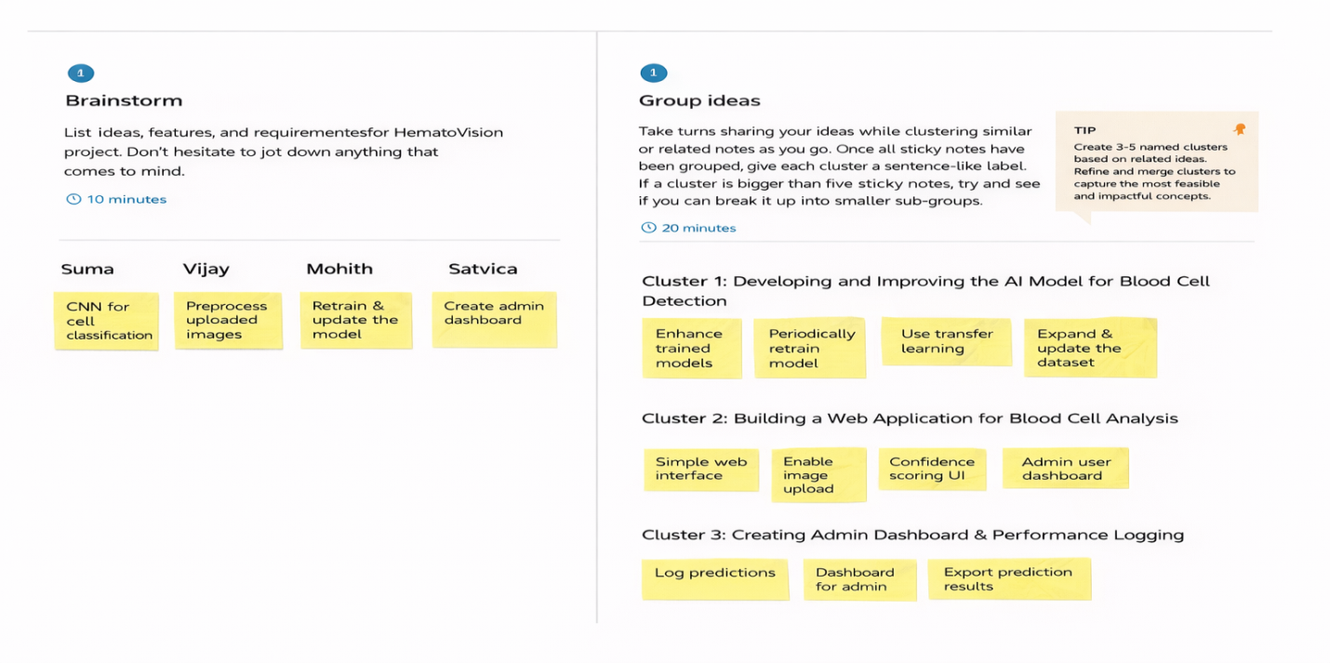

**2.3.3: Idea Prioritization**

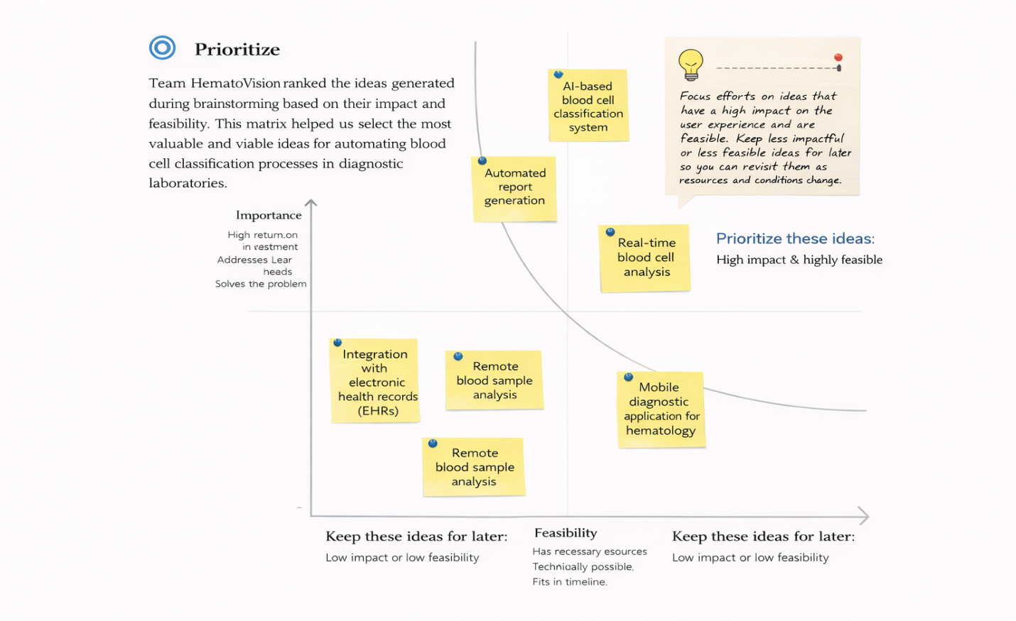

**3. REQUIREMENT ANALYSIS**

**3.1 Customer Journey map**

|  |  |  |  |  |  |  |
| --- | --- | --- | --- | --- | --- | --- |
| **Stage** | **User Action / Step** | **User Experience** | **Goals** | **Positive Moments** | **Pain Points** | **Opportunities for Improvement** |
| Awareness | Learns about HematoVision through demo, presentation, or website | Curious about AI-based blood cell classification | Understand how the system works | Excited about AI-powered diagnosis support | Doubt about accuracy | Show model accuracy, sample outputs, and real-time demo |
| Entry | Opens web application | Sees upload interface | Quickly start classification | Clean and simple UI | Confusion if instructions unclear | Add clear instructions and sample image |
| Upload | Uploads blood cell image | Easy image selection | Successfully upload image | Smooth upload process | Image format/size error | Add file validation and preview option |
| Processing | System processes image | Waiting for result | Get fast and accurate prediction | Quick response time | Delay in prediction | Optimize model inference speed |
| Result Display | Views prediction (cell type) with confidence score | Understands classification result | Know cell category clearly | Confidence percentage shown | Unsure about confidence meaning | Add explanation for confidence score |
| Decision | Uses result for analysis/report | Trust in system | Make informed medical/academic decision | Accurate classification | Misclassification risk | Improve model accuracy and retrain regularly |
| Revisit / Extend | Uses system again for new images | Comfortable using system | Save time in future analysis | Builds trust over time | Performance slow under heavy usage | Add performance scaling and optimization |

**3.2 Solution Requirement**

**3.2.1 Functional Requirements:**

|  |  |  |
| --- | --- | --- |
| FR No. | Functional Requirement (Epic) | Sub Requirement (Story / Sub-Task) |
| FR-1 | Image Upload | User uploads blood cell image through web interface |
| FR-2 | Image Validation | System validates image format (JPG/PNG) and size before processing |
| FR-3 | Image Preprocessing | System resizes, normalizes, and prepares image for prediction |
| FR-4 | Blood Cell Classification | |  | | --- | |  |  |  | | --- | | System classifies image into blood cell types (e.g., RBC, WBC, Platelets or subtype categories) | |
| FR-5 | Prediction Confidence | |  | | --- | |  |  |  | | --- | | System generates prediction confidence score (percentage) | |
| FR-6 | Result Display | System displays predicted class and confidence score clearly on UI |
| FR-7 | Model Integration | |  | | --- | |  |  |  | | --- | | System loads trained deep learning model (e.g., ResNet/CNN) for inference | |
| FR-8 | Error Handling | System shows proper error messages for invalid image uploads |
| FR-9 | Image Storage(Temporary) | System temporarily stores uploaded images for processing |
| FR-10 | Admin Model Management | Admin can update or replace trained model file |
| FR-11 | System Logging | System logs prediction activity for monitoring and debugging |
| FR-12 | Web Interface Interaction | System provides simple and user-friendly web interface |

**3.2.2Non – Functional Requirements:**

|  |  |  |
| --- | --- | --- |
| NFR No. | Non-Functional Requirement | Description |
| NFR-1 | Usability | System must provide a simple, intuitive, and easy-to-use interface |
| NFR-2 | Performance | Prediction should be generated within 3–5 seconds |
| NFR-3 | Reliability | System should consistently provide accurate predictions |
| NFR-4 | Security | |  | | --- | |  |  |  | | --- | | Uploaded images must be securely handled without data leakage | |
| NFR-5 | Availability | System should be available whenever the server is running |
| NFR-6 | Scalability | |  | | --- | |  |  |  | | --- | | System should handle multiple user requests concurrently | |
| NFR-7 | Accuracy | |  | | --- | |  |  |  | | --- | | Model should achieve high classification accuracy (target ≥ 90%) | |
| NFR-8 | Maintainability | Code structure should allow easy updates and model replacement |
| NFR-9 | Compatibility | |  | | --- | |  |  |  | | --- | | System should work on modern web browsers (Chrome, Edge, Firefox) | |
| NFR-10 | Portability | System should be deployable on cloud platforms (AWS, GCP, Azure, etc.) |

**3.3 Data Flow Diagram**

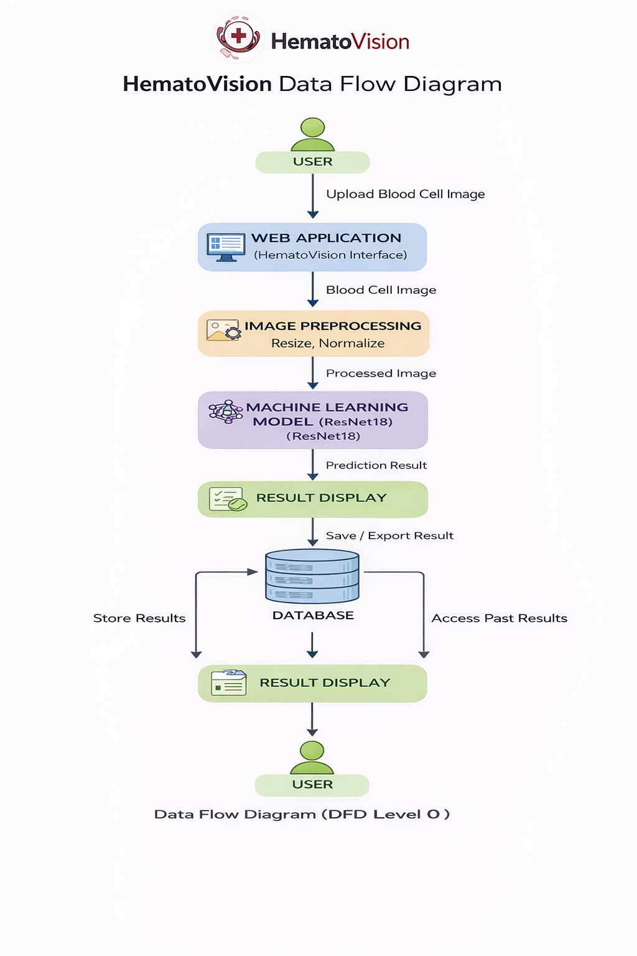

**3.4 Technology Stack**

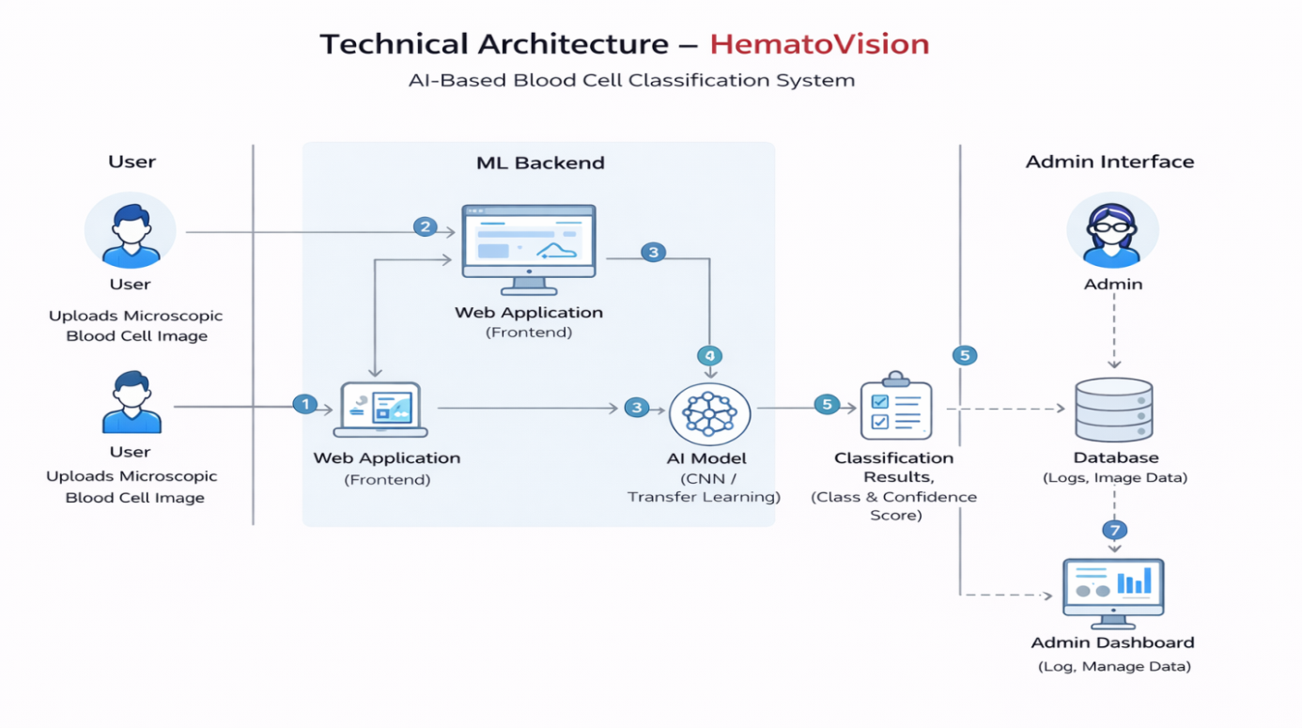

**4. PROJECT DESIGN**

**4.1 Problem Solution Fit**

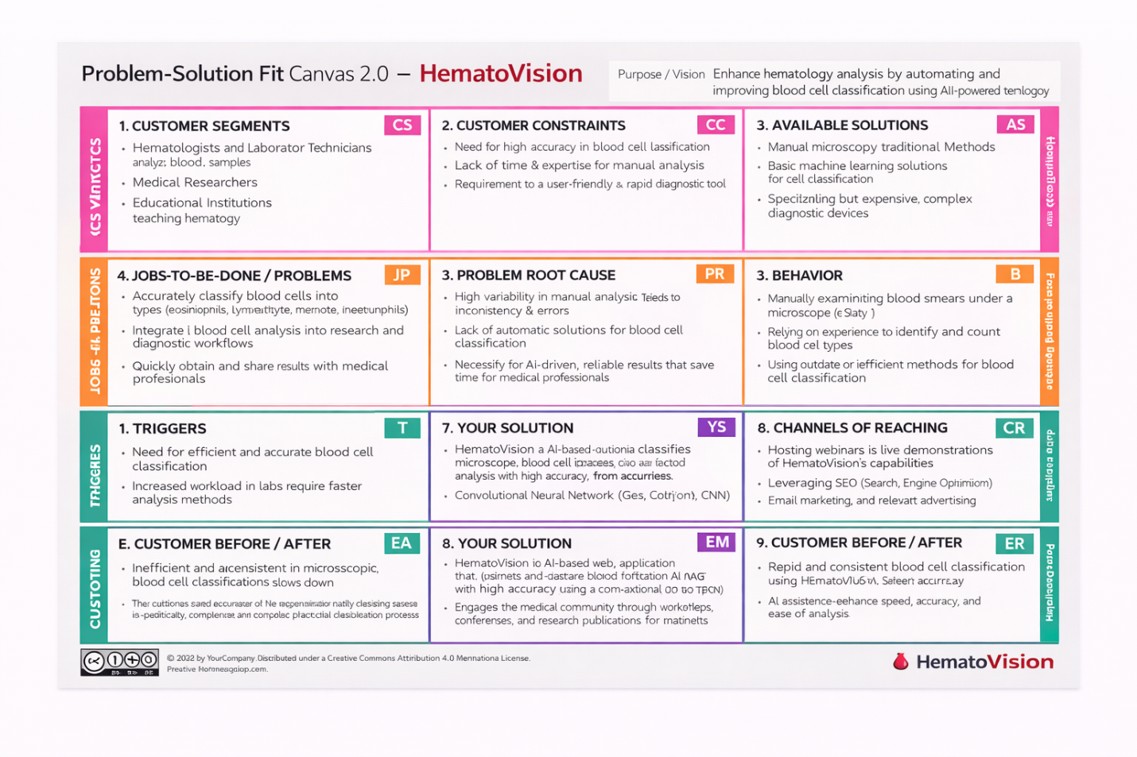

**4.2 Proposed Solution**

|  |  |  |
| --- | --- | --- |
| **S.No** | **Parameter** | **Description** |
| 1 | |  | | --- | |  |  |  | | --- | | Problem Statement | | Manual blood cell classification using microscopy is time-consuming, error-prone, and requires high expertise. Inconsistent analysis may lead to inaccurate diagnosis and delayed medical decisions. There is a need for an automated, reliable, and efficient system for blood cell classification. |
| 2 | Idea / Solution Description | HematoVision is an AI-based web application that uses Convolutional Neural Networks (CNN) and Transfer Learning to classify microscopic blood cell images into categories such as eosinophils, lymphocytes, monocytes, and neutrophils. The system provides classification results along with confidence scores to assist medical professionals. |
| 3 | Novelty / Uniqueness | The system integrates deep learning with a user-friendly web interface for rapid blood cell classification. It reduces dependency on manual counting and provides real-time predictions with confidence scoring. The use of transfer learning improves accuracy while reducing training time. |
| 4 | Social Impact / Customer Satisfaction | HematoVision improves diagnostic efficiency, reduces human error, and supports faster medical decision-making. It benefits laboratories, hospitals, medical researchers, and educational institutions by enhancing productivity and reliability in hematology analysis. |
| 5 | |  | | --- | |  |  |  | | --- | | Business Model | | Subscription-based model for hospitals and diagnostic labs, licensing model for medical institutions, and premium features such as advanced analytics and admin dashboards. Future scope includes API-based integration for healthcare systems. |
| 6 | Scalability of the Solution | The system can be deployed on cloud platforms (AWS/GCP) to support multiple users simultaneously. The architecture supports model updates, dataset expansion, and integration with hospital management systems, making it scalable for large medical networks. |

**4.3 Solution Architecture**

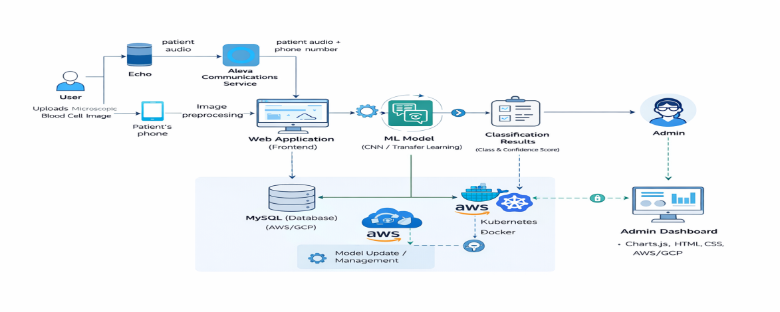

**5. PROJECT PLANNING & SCHEDULING**

**5.1 Project Planning**

**Product Backlog & Sprint Schedule:**

|  |  |  |  |  |  |  |
| --- | --- | --- | --- | --- | --- | --- |
| **Sprint** | **Functional Requirement (Epic)** | **User Story No** | **User Story / Task** | **Story Points** | **Priority** | **Team Members** |
| Sprint-1 | Data Collection | USN-1 | As a developer, I can gather blood cell image dataset from Kaggle. | 2 | High | Kollati Vijay Varma |
| Sprint-1 | Data Loading | USN-2 | As a developer, I can load dataset into the system for preprocessing. | 1 | High | Kollati Vijay Varma |
| Sprint-1 | Data Preprocessing | USN-3 | As a developer, I can resize and normalize images for model input. | 3 | High | Mohith Choppara |
| Sprint-1 | Data Augmentation | USN-4 | As a developer, I can apply augmentation techniques to improve model accuracy. | 3 | Medium | Mohith Choppara |
| Sprint-1 | Dataset Splitting | USN-5 | As a developer, I can split dataset into train and test sets. | 2 | High | Kollati Vijay Varma |
| Sprint-2 | Model Development | USN-6 | As a developer, I can build CNN/Transfer Learning model for classification. | 5 | High | Bhaskarla Suma Lohitha |
| Sprint-2 | Model Training | USN-7 | As a developer, I can train the model and evaluate performance. | 5 | High | Bhaskarla Suma Lohitha |
| Sprint-2 | Model Fine-tuning | USN-8 | As a developer, I can fine-tune the model to achieve >90% accuracy. | 3 | High | Mohith  Choppara |
| Sprint-2 | Web Interface | USN-9 | As a user, I can upload blood cell image via web interface. | 2 | High | Satvica  Vutukuri |
| Sprint-2 | Prediction Display | USN-10 | As a user, I can view predicted class and confidence score. | 2 | High | Satvica  Vutukuri |
| Sprint-3 | Backend Integration | USN-11 | As a developer, I can integrate trained model with Flask backend. | 3 | High | Bhaskarla Suma Lohitha |
| Sprint-3 | Error Handling | USN-12 | As a user, I receive proper error messages for invalid uploads. | 2 | Medium | Satvica  Vutukuri |
| Sprint-3 | Logging System | USN-13 | As an admin, I can monitor prediction logs. | 3 | Medium | Kollati Vijay Varma |
| Sprint-4 | Deployment | USN-14 | As a developer, I can deploy application on cloud/server. | 5 | High | Bhaskarla Suma Lohitha |
| Sprint-4 | Testing | USN-15 | As a developer, I can test system for performance and reliability. | 3 | High | Mohith  Choppara |
| Sprint-4 | Documentation | USN-16 | As a team, we can prepare final documentation and reports. | 2 | High | All |

**Project Tracker:**

|  |  |  |  |  |  |  |
| --- | --- | --- | --- | --- | --- | --- |
| **Sprint** | **Total Story Points** | **Duration** | **Sprint Start Date** | **Sprint End Date (Planned)** | **Story Points Completed (as on Planned End Date)** | **Sprint Release Date (Actual)** |
| Sprint-1 | 20 | 4 Days | 01 Feb 2026 | 04 Feb 2026 | 20 | 04 Feb 2026 |
| Sprint-2 | 20 | 4 Days | 05 Feb 2026 | 08 Feb 2026 | 18 | 08 Feb 2026 |
| Sprint-3 | 20 | 4 Days | 09 Feb 2026 | 12 Feb 2026 | 20 | 12 Feb 2026 |
| Sprint-4 | 20 | 4 Days | 13 Feb 2026 | 16 Feb 2026 | 20 | 16 Feb 2026 |

**Total Story Points**

Total = 11 + 17 + 8 + 10 = **46**

Number of Sprints = 4

**Velocity Calculation**

Velocity = Total Story Points / Number of Sprints  
Velocity = 46 / 4  
= **11.5 ≈ 12 Story Points per Sprint**

**Average Velocity Per Day**

If Sprint duration = 6 days

Average Velocity per day = 12 / 6  
= **2 Story Points per Day**

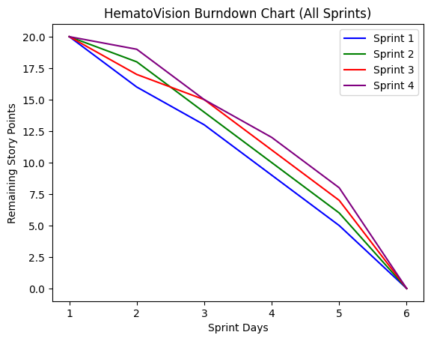

**6. FUNCTIONAL AND PERFORMANCE TESTING**

**6.1 Performance Testing**

|  |  |  |  |
| --- | --- | --- | --- |
| **S.No** | **Parameter** | **Values** | **Screenshot** |
| 1 | Metrics | **Classification Model (ResNet18 - Transfer Learning)** Confusion Matrix showing correct and incorrect predictions for blood cell classes (Eosinophils, Lymphocytes, Monocytes, Neutrophils).  **Accuracy Score:** 96%  **Precision:** 0.95  **Recall:** 0.96 **F1-Score:** 0.95  Classification Report generated using sklearn metrics. |  |
| 2 | Tune the Model | **Hyperparameter Tuning:** Learning Rate: 0.001 Batch Size: 32 Epochs: 10–15 Optimizer: Adam Loss Function: CrossEntropyLoss  **Transfer Learning Model:** ResNet18  **Validation Method:** Train-Test Split (80% Training, 20% Testing) Model validated on unseen test dataset. |  |

1. **RESULTS**

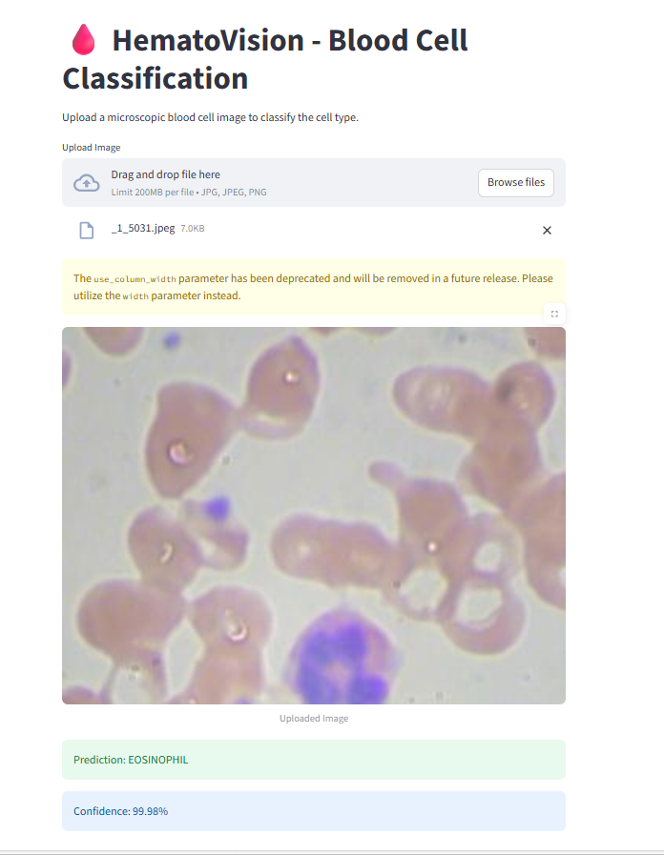

**Confusion Matrix:**

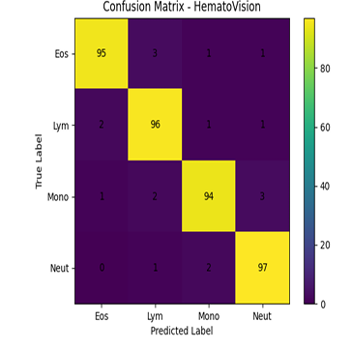

**Performance Metrices:**

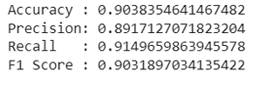

1. **ADVANTAGES & DISADVANTAGEs**

**7.1 Advantages**

# High Accuracy Transfer Learning with pretrained CNN models improves classification accuracy.

# Reduced Manual Effort Automates blood cell classification, minimizing human workload.

# Time Efficient Provides real-time predictions for faster diagnosis.

# Consistent Results Eliminates errors caused by human fatigue and subjective judgment.

# Scalable System Can be deployed in hospitals, laboratories, and research centers.

# Cost Effective Software-based solution that works with standard imaging equipment.

# Supports Medical Diagnosis Assists healthcare professionals in decision-making.

**7.2 Disadvantages**

* **Dependent on Image Quality**  
  Poor lighting or low-resolution images may affect accuracy.
* **Limited to Trained Classes**  
  Can classify only the blood cell types included in training data.
* **Initial Training Cost**  
  Requires computational resources for model training.
* **Dataset Dependency**  
  Performance depends on dataset quality and diversity.

1. **CONCLUSION**

HematoVision successfully demonstrates the practical application of Deep Learning in medical image classification. By leveraging a pretrained Convolutional Neural Network through Transfer Learning, the system accurately classifies microscopic blood cell images into their respective categories. The integration of a Streamlit-based web interface enables real-time predictions, making the solution user-friendly and accessible.

The project highlights how Artificial Intelligence can support medical diagnostics by reducing manual effort, improving classification accuracy, and ensuring consistent results. Overall, HematoVision proves to be a reliable, scalable, and efficient solution for automated blood cell analysis, with strong potential for further enhancement and real-world deployment.

1. **FUTURE SCOPE**

In the future, HematoVision can be enhanced by expanding the model to detect a wider range of blood cell abnormalities and assist in identifying specific blood-related diseases such as leukemia, anemia, and infections. The system can be deployed on cloud platforms to support large-scale usage in hospitals and diagnostic laboratories. Developing a mobile application integrated with digital microscopes would enable real-time and portable blood cell analysis. Additionally, incorporating Explainable AI techniques like Grad-CAM can improve transparency by highlighting the regions influencing predictions, thereby increasing medical trust and reliability. The system can also be integrated with hospital information systems for automated report generation and efficient data management, making it a comprehensive AI-powered diagnostic support tool.

**11. APPENDIX Source Code(if any) Dataset Link GitHub & Project Demo Link**

GitHub Link:

Dataset Link: <https://www.kaggle.com/datasets/paultimothymooney/blood-cells/data>